**ExploreAtlas**

**ABSTRACT**

Explore Atlas is a web-based application designed to guide users to explorative adventures by discovering and sharing captivating natural terrains, such as viewpoints, trekking routes, camping spots, scenery landmarks and more such natural places. Inspired by the spirit of exploration, Explore Atlas provides an interactive platform for adventurers to document and review their discoveries.   
  
The application leverages a modern technology stack, including Node.js, Express, EJS, MongoDB, and Mongoose, to deliver a robust and scalable solution. Key features of Explore Atlas include user authentication, CRUD operations for spots or locations, an interactive map services from MapBox to display locations in a map, and seamless image management using cloud repository Cloudinary. .  
  
This report details the development process, system design, implementation, technology stack and future enhancements of Explore Atlas, highlighting its potential to foster a community of explorers who share a passion for discovering the world's hidden gems.

i

Table of Contents

ABSTRACT i

CHAPTER 1 6

INTRODUCTION 6

CHAPTER 2 7

OBJECTIVES 7

CHAPTER 3 8

TECHNOLOGY STACK 8

CHAPTER 4 13

SYSTEM FLOW AND ARCHITECTURE 13

CHAPTER 5 15

IMPLEMENTATION 15

CHAPTER 6 22

CONCLUSION AND FUTURE SCOPE 22

List Of Figures

|  |  |  |
| --- | --- | --- |
| Fig 4.1 | Flow of Navigation | 14 |
| Fig 5.1 | Home Page | 15 |
| Fig 5.2 | Main Page | 15 |
| Fig 5.3 | List of Terrains | 16 |
| Fig 5.4 | Interactive Map | 16 |
| Fig 5.5 | Display of Spot | 17 |
| Fig 5.6 | Adding a New Terrain | 17 |
| Fig 5.7 | Addition of New Terrain | 18 |
| Fig 5.8 | Edit Terrain | 18 |
| Fig 5.9 | Login Page | 19 |
| Fig 5.10 | Register Page | 19 |
| Fig 5.11a | MongoDB Atlas | 20 |
| Fig 5.11b | MongoDB Atlas | 20 |
| Fig 5.12 | Cloudinary | 21 |
| Fig 5.13 | MapBox | 21 |

**Chapter 1: INTRODUCTION**

Explore Atlas is an innovative web application designed to help users discover and share natural terrains such as viewpoints, trekking routes, and camping spots. Inspired by the spirit of exploration, this project aims to provide an interactive platform for adventurers to document and review their discoveries.

In an era where digital platforms play a crucial role in connecting people and enhancing their experiences, Explore Atlas emerges as an innovative solution for outdoor enthusiasts and adventurers. The project aims to create a comprehensive guide to the world's most captivating natural terrains, including viewpoints, trekking routes, and camping spots. Explore Atlas not only allows users to discover and add new places but also provides a platform to share their experiences through reviews and comments, fostering a community of like-minded explorers.

The inspiration for Explore Atlas comes from the popular video game Uncharted, which follows a crew of treasure hunters traveling across the globe to uncover historical mysteries. This sense of adventure and discovery is embedded in the design and functionality of Explore Atlas, encouraging users to explore uncharted territories and share their findings with others.

The report will provide an in-depth look at the development process, from initial design and architecture to implementation and testing. It will also discuss the challenges encountered, solutions implemented, and potential future enhancements to further improve the user experience. By documenting the journey of creating Explore Atlas, this report aims to showcase the project's potential to become a valuable resource for adventurers seeking to explore and share the world's hidden treasures.

## Chapter 2: OBJECTIVES

The main objectives of Explore Atlas are:

* To provide a platform for users to discover landmarks and spots.
* To allow the registered users to add new locations to the list.
* To allow them to add reviews and rating for their discovered location.
* To allow the registered users to delete their added locations to the list.
* To allow the registered users to leave rating and review on other locations as well.
* To allow the registered users to delete their rating and review on locations.
* To display locations on an interactive map.
* To allow users to interact with the map by sliding, scrolling, and scaling it.
* To create a community of explorers who can interact and share experiences.

### 

### Chapter 3: TECHNOLOGY STACK

**HTML and CSS**

HTML (HyperText Markup Language) and CSS (Cascading Style Sheets) form the backbone of the front-end development in Explore Atlas. HTML provides the structure and content of the web pages, while CSS is used to control the presentation, formatting, and layout. Together, they ensure that the user interface is both functional and visually appealing.

In Explore Atlas, HTML and CSS are used to structure and style the web pages, ensuring a visually appealing and user-friendly interface. HTML provides the backbone of the web pages, defining the content and layout, while CSS is used to apply styles, colors, fonts, and layouts. This combination allows for the creation of responsive web pages that look great on various devices and screen sizes, enhancing the overall user experience.

**Node.js**

Node.js is a powerful server-side JavaScript runtime environment that enables developers to build scalable and efficient web applications. Built on Chrome's V8 JavaScript engine, Node.js allows for the execution of JavaScript code outside the browser, making it possible to create server-side applications with JavaScript.

Node.js is the core of the server-side logic in Explore Atlas. It handles incoming HTTP requests, processes them, and sends appropriate responses back to the client. By leveraging Node.js, the application can efficiently manage asynchronous operations, such as database queries and file handling, ensuring a smooth and responsive user experience. Node.js's non-blocking I/O capabilities make it ideal for handling the real-time interactions required by Explore Atlas.

**Express**

Express is a minimal and flexible Node.js web application framework that provides a robust set of features for building web and mobile applications. It simplifies the process of handling HTTP requests and defining routes, making it easier to build RESTful APIs and web applications. In Explore Atlas, Express is used to create the server-side logic, manage routing, and handle various HTTP methods such as GET, POST, PUT, and DELETE.

This enables seamless interaction between the client and server, facilitating the addition, retrieval, updating, and deletion of data. Express is used as the web application framework in Explore Atlas, simplifying the development of server-side logic. It handles routing, enabling the application to define various endpoints for different functionalities, such as viewing, adding, editing, and deleting spots. Express also manages middleware functions, which are used for tasks like authentication, error handling, and request parsing. This streamlined approach allows for clean and maintainable code.

**EJS**

EJS (Embedded JavaScript Templating) is a templating engine that allows developers to embed JavaScript code within HTML. This makes it possible to create dynamic web pages that can render data from the server. In Explore Atlas, EJS is used to generate HTML pages on the server side, providing a way to inject dynamic content into web pages. This approach ensures that users receive personalized and contextually relevant information, enhancing the overall user experience. EJS is used to render dynamic web pages in Explore Atlas. By embedding JavaScript code within HTML templates, EJS allows the server to generate HTML pages with dynamic content based on user input and data retrieved from the database. This ensures that users receive personalized and contextually relevant information, such as lists of SPOTS, user reviews, and interactive maps.

**MongoDB**

MongoDB is a NoSQL database that provides a flexible and scalable solution for storing hierarchical data. Unlike traditional relational databases, MongoDB uses a document-oriented model, allowing for the storage of complex data structures in JSON-like documents. In Explore Atlas, MongoDB is used to store various types of data, including user profiles, SPOTS, reviews, and images. Its schema-less nature allows for easy and efficient management of evolving data models, making it an ideal choice for the dynamic and diverse data requirements of the application. This includes user profiles, SPOTS, reviews, and images.

MongoDB's flexible schema design allows for easy management of diverse and evolving data models, making it well-suited for the dynamic nature of Explore Atlas. The database efficiently handles CRUD operations, ensuring fast and reliable data access.

**Mongoose**

Mongoose is an Object Data Modeling (ODM) library for MongoDB and Node.js. It provides a straightforward and schema-based solution for modeling application data, making it easier to work with MongoDB in a Node.js environment. Mongoose allows developers to define schemas for their data models and includes built-in type casting, validation, query building, and business logic hooks. In Explore Atlas, Mongoose is used to define the structure of data objects, enforce data integrity, and streamline interactions with the MongoDB database.

It provides a schema-based solution for modeling application data, allowing for the definition of clear and consistent data structures. In Explore Atlas, Mongoose schemas are used to define the structure of SPOTS, user profiles, and reviews, enforcing data integrity and validation. This makes it easier to perform database operations and manage relationships between different data entities.

**Passport**

Passport is a popular authentication middleware for Node.js that simplifies the process of implementing user authentication. It supports a wide range of authentication strategies, including local authentication using username and password, as well as OAuth-based authentication for third-party services. In Explore Atlas, Passport is used to handle user authentication, allowing users to register, log in, and access restricted features of the application. By leveraging Passport, Explore Atlas ensures secure and reliable authentication mechanisms, enhancing the overall security of the application.

Passport is employed for user authentication in Explore Atlas. It provides a range of authentication strategies, allowing users to register, log in, and access restricted features. By integrating Passport, the application ensures secure authentication processes, protecting user data and preventing unauthorized access. This enhances the security and reliability of the application, providing users with a safe environment to explore and share their discoveries.

**MongoDB Atlas**

MongoDB Atlas is a cloud-based service that provides a fully managed MongoDB database. It handles the complexities of deploying, managing, and scaling MongoDB clusters, allowing developers to focus on building their applications without worrying about database infrastructure. This cloud-based deployment enhances the application's performance and reliability, providing a seamless experience for users.

MongoDB Atlas is used to host the Explore Atlas database in the cloud, providing a fully managed and scalable solution. This cloud-based deployment ensures high availability, automatic backups, and seamless scaling as the application grows. MongoDB Atlas handles the complexities of database management, allowing the development team to focus on building and improving the application without worrying about infrastructure.

**Cloudinary**

Cloudinary is a cloud-based image storage and management service that offers a comprehensive solution for handling multimedia content. It provides features such as image uploading, storage, transformation, and delivery, making it easy to manage and optimize images for web applications. In Explore Atlas, Cloudinary is used to store and manage images of spots added by users.

Cloudinary is integrated into Explore Atlas for image storage and management. It allows users to upload images of SPOTS, which are then stored and managed in the cloud. Cloudinary provides powerful image transformation capabilities, enabling the application to optimize and deliver images efficiently. This ensures that images are displayed quickly and correctly, enhancing the visual appeal of the application and providing users with an engaging experience.

**MapBox**

MapBox is a powerful mapping and location data platform that provides APIs for integrating interactive maps into web and mobile applications. It offers a wide range of features, including customizable maps, geocoding, routing, and spatial analysis. This allows users to visualize and explore various natural terrains on a map, enhancing their discovery experience.

MapBox is used to integrate interactive maps into Explore Atlas, allowing users to visualize and explore spots on a map. The integration of MapBox enables seamless interaction with map features, such as adding new locations and viewing checkpoints, making the application more engaging and user-friendly. The MapBox APIs enable features such as customizable maps, geocoding, and spatial analysis, making it easy to add and display new locations. This interactive mapping functionality enhances the user experience by providing a clear and intuitive way to discover and navigate various natural terrains, making the application more engaging and informative.

### Chapter 4: SYSTEM FLOW and ARCHITECTURE

The interactions between the components of web application follow a well-defined flow to ensure smooth and efficient operation:

User Requests: The user interacts with the client-side application, triggering events such as viewing SPOTS, adding new SPOTS, or posting reviews.

Client-Side Processing: JavaScript on the client-side handles initial validations and sends AJAX requests to the server for processing.

Server-Side Handling: The Express server receives the requests, processes them using defined routes, and performs necessary business logic. It may involve querying the MongoDB database or interacting with external APIs.

Database Interactions: Using Mongoose, the server interacts with MongoDB to retrieve, insert, update, or delete data as needed. The results are sent back to the server.

API Integrations: If the request involves image handling or map-related data, the server communicates with Cloudinary or MapBox APIs. For instance, images are uploaded to Cloudinary, and geocoding is handled by MapBox.

Response to Client: After processing the request, the server sends the appropriate response back to the client. This could include HTML rendered using EJS, JSON data for dynamic updates, or status messages.

Client Updates: The client-side JavaScript updates the DOM based on the server's response, providing real-time feedback to the user and updating the UI accordingly.

Figure 0‑1: Flow of Navigation

Figure 4. 1: Flow of Navigation

**Chapter 5: IMPLEMENTATION**

Home Page

Main Page

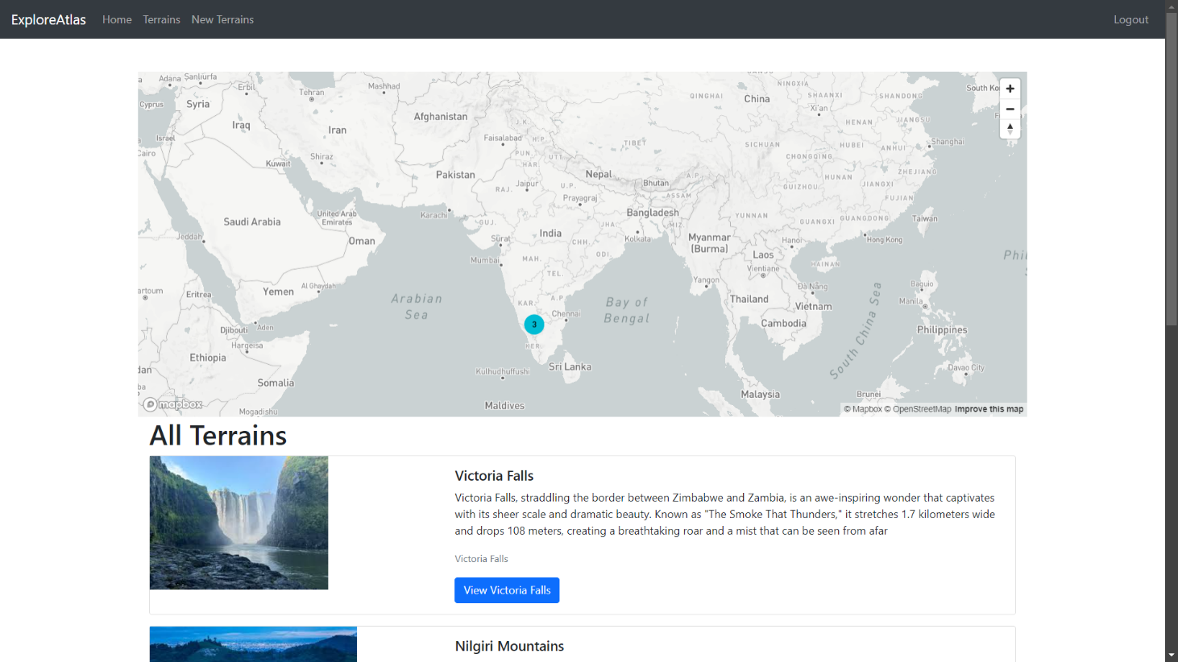

List of Terrains

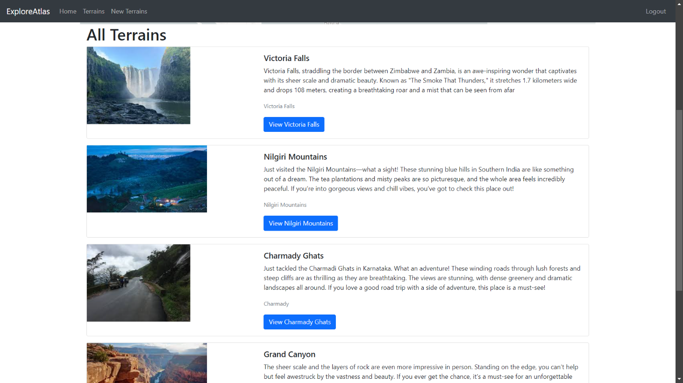

Interactive Map

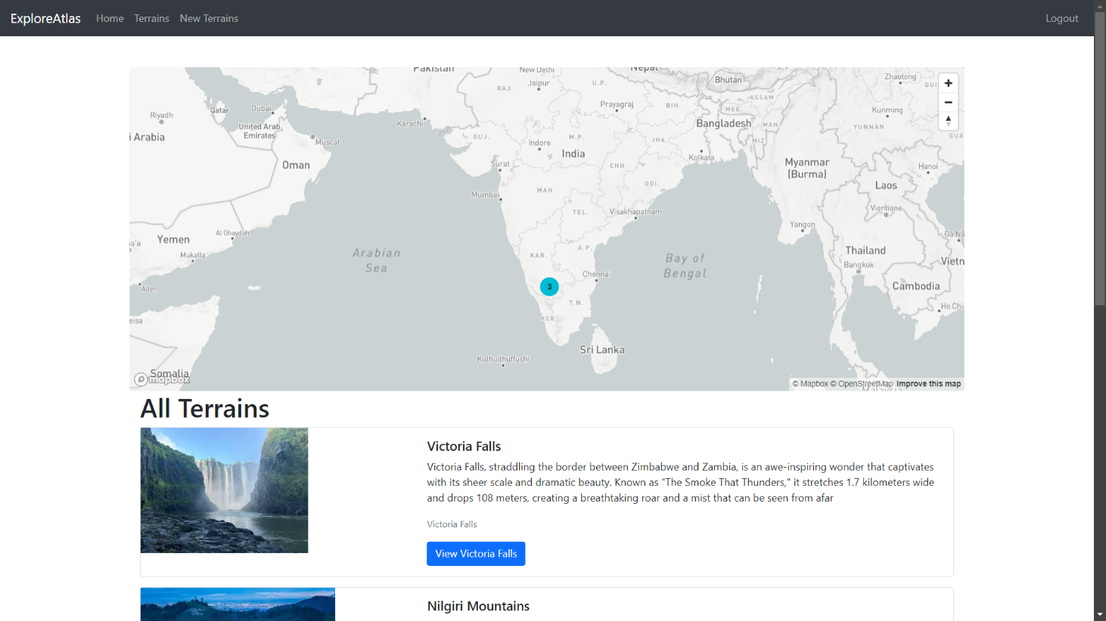

Display of Spot

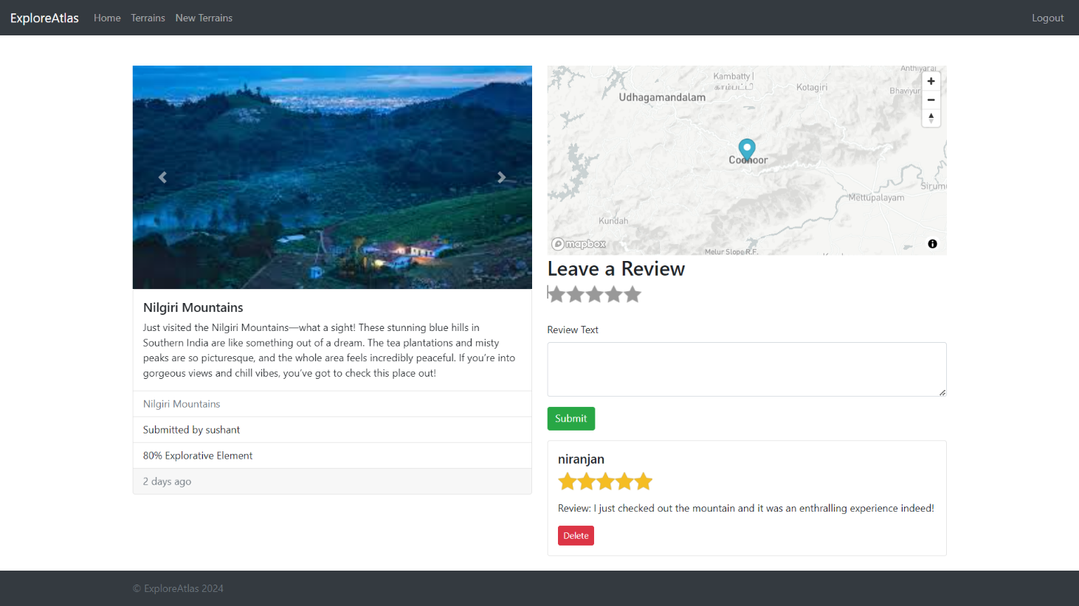

Adding a New Terrain

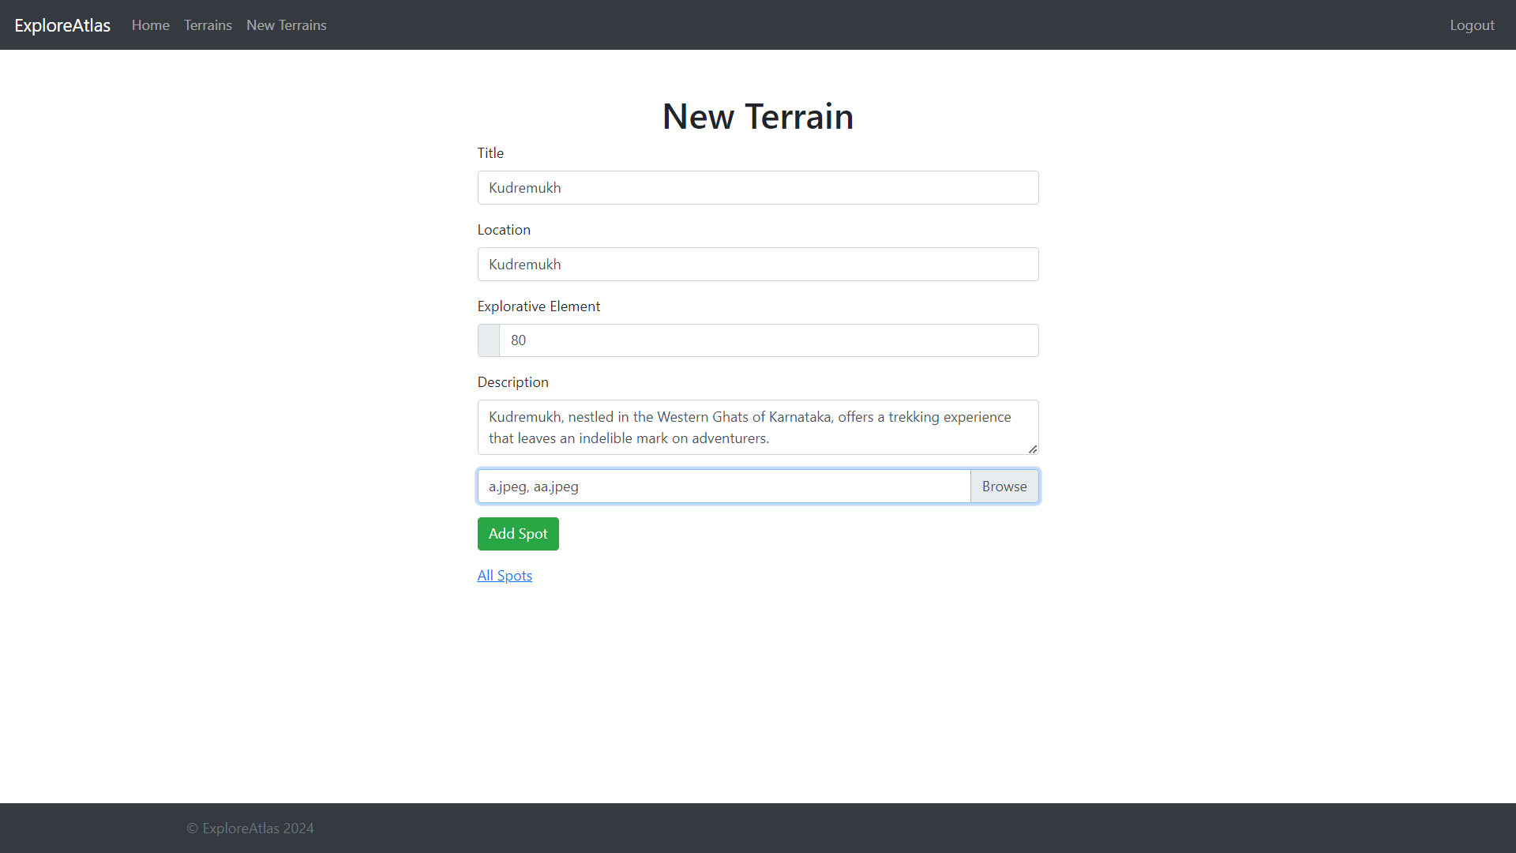

Adding a New Terrain

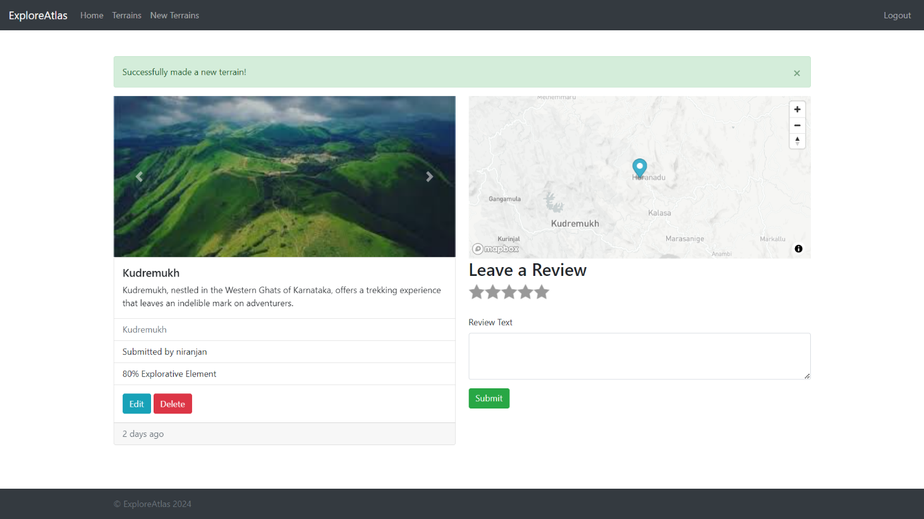

Edit Terrain

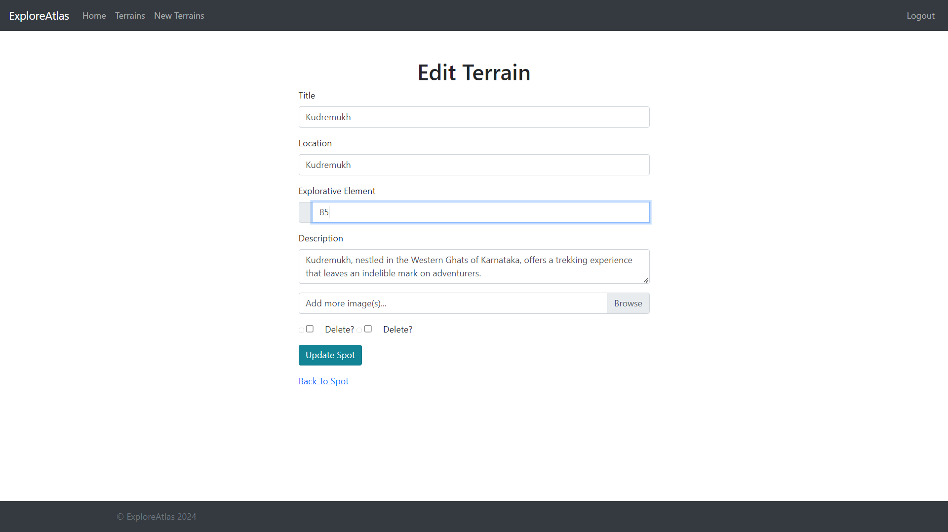

Login Page

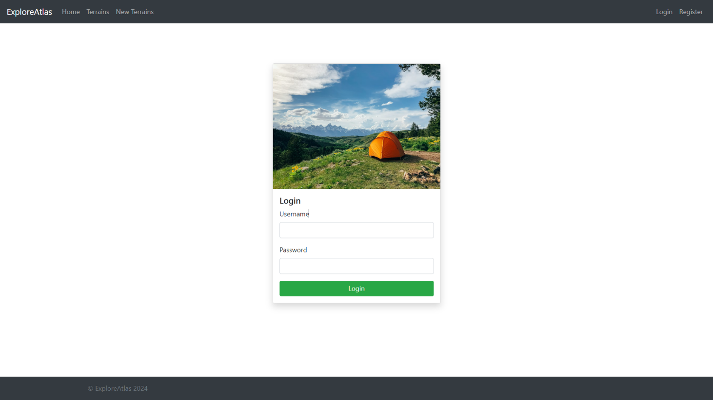

Register Page

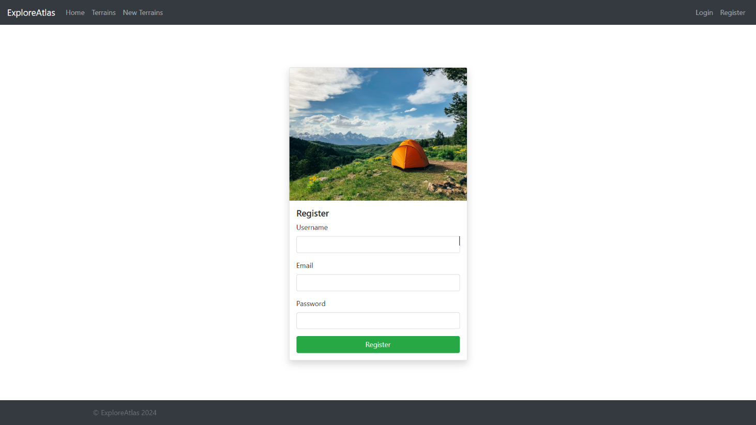

**Services and API used**

MongoDB Atlas

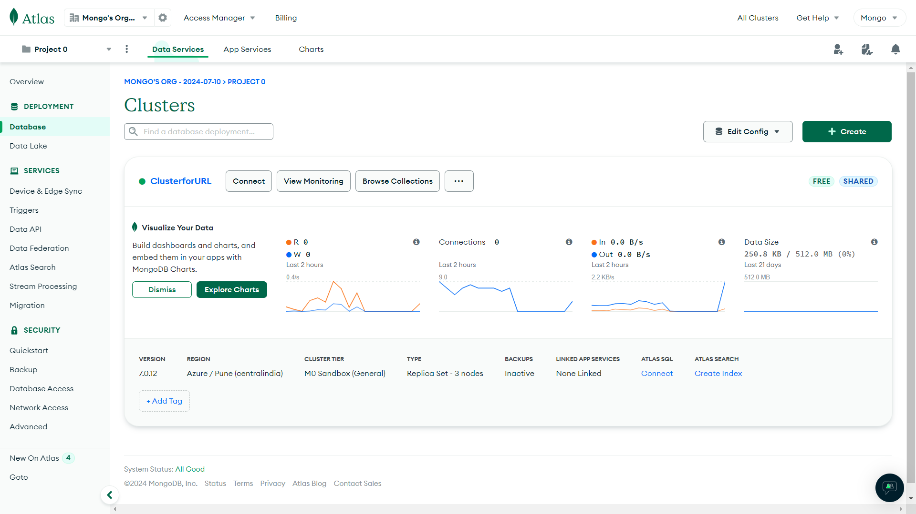

MongoDB Atlas

Cloudinary

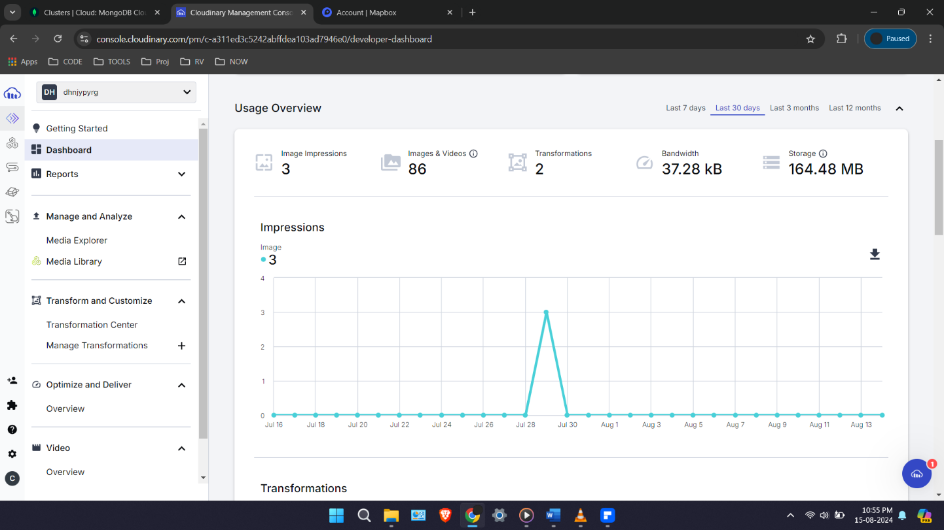

MapBox

# CHAPTER 7: CONCLUSION and FUTURE SCOPE

Explore Atlas stands as a testament to the power of modern web technologies in creating dynamic, interactive, and user-centric applications. From its inception, the project aimed to harness the spirit of exploration and discovery, providing a platform for adventurers to document and share their experiences of the world's hidden gems. The successful development and deployment of Explore Atlas underscore the importance of a well-architected system that seamlessly integrates client-side and server-side technologies with robust database management and powerful external services.

The use of HTML, CSS, and JavaScript on the client side ensured a responsive and engaging user interface. By adhering to best practices in front-end development, the project delivers a visually appealing and user-friendly experience across various devices and screen sizes. The dynamic content rendering facilitated by EJS further enhances the interactivity and personalization of the web pages, making the application more appealing to users.

On the server side, Node.js and Express form the backbone of Explore Atlas, enabling efficient handling of HTTP requests, routing, and business logic. The asynchronous nature of Node.js, coupled with the simplicity and flexibility of Express, allows for the smooth execution of server-side operations. This combination ensures that the application remains responsive and scalable, capable of handling a growing number of users and interactions.

MongoDB and Mongoose play a crucial role in managing the application's data. The document-oriented model of MongoDB offers flexibility in storing hierarchical data structures, while Mongoose's schema-based approach ensures data integrity and consistency. This powerful combination allows for efficient data retrieval and manipulation, supporting the dynamic nature of Explore Atlas.

The integration of external services such as Cloudinary and MapBox significantly enhances the application's functionality. Cloudinary's robust image management capabilities ensure efficient storage, transformation, and delivery of images, while MapBox provides powerful mapping and geolocation features. These integrations offer users a seamless and enriched experience.

Explore Atlas also demonstrates the importance of secure and reliable authentication mechanisms. By implementing Passport for user authentication, the project ensures that user data is protected and only authorized users can access restricted features. This focus on security and user privacy is crucial for building trust and fostering a safe online community.

Throughout the development of Explore Atlas, several challenges were encountered, including managing complex data relationships, ensuring real-time responsiveness, and integrating multiple external services. Each challenge was addressed through careful planning, iterative development, and thorough testing, resulting in a robust and reliable application.

Looking forward, there are numerous opportunities for enhancing Explore Atlas. Future iterations could include features such as real-time chat for users, more advanced search and filtering options, and integration with additional third-party services for enriched data and functionalities. These enhancements would further solidify Explore Atlas as a comprehensive guide for adventurers seeking to explore and share uncharted territories.

In conclusion, Explore Atlas exemplifies the effective use of modern web technologies to create a compelling and functional application. By leveraging a well-thought-out system architecture and integrating powerful tools and services, the project successfully delivers on its vision of guiding users to uncharted adventures. The lessons learned and experiences gained during this project serve as valuable foundations for future developments, promising continued innovation and improvement in the field of web application development.